# Data Structures and Algorithms

# INFO 6205

# Homework 9

# Due: July 26, 2020

Put all your java, compiled class files and documentation files into a zip file named Homework9.zip and submit it via the dropbox on the blackboard before the END of due date. Put your name on all .java files. There will be a short Quiz on this homework.

1. Consider the following Graph,

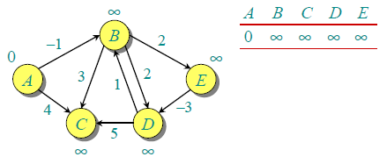

a) Solve the Shortest path of this graph using Bellman-Ford algorithm, step-by-step

b) Random Ordering is used to select the ordering of the algorithm steps.

In worse case, how many iterations are required by the algorithm

to consider all Vertices?

c) Consider the following bellman-ford graph, A negative “cycle” makes the path

shorter and shorter: What does that mean? How to test for negative cycle?

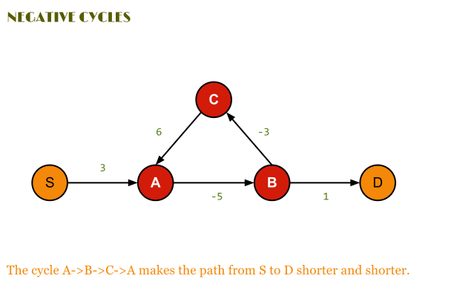

d) Write the Java code for the graph considering the following Algorithms:

<https://algorithm.programmingpedia.net/en/tutorial/4791/bellman-ford-algorithm>

Procedure Bellman-Ford(Graph, source):

n := number of vertices in Graph

for i from 1 to n

d[i] := infinity

parent[i] := NULL

end for

d[source] := 0

for i from 1 to n-1

flag := false

for all edges from (u,v) in Graph

if d[u] + cost[u][v] < d[v]

d[v] := d[u] + cost[u][v]

parent[v] := u

flag := true

end if

end for

if flag == false

break

end for

Return d

Procedure Bellman-Ford-With-Negative-Cycle-Detection(Graph, source):

n := number of vertices in Graph

for i from 1 to n

d[i] := infinity

parent[i] := NULL

end for

d[source] := 0

for i from 1 to n-1

flag := false

for all edges from (u,v) in Graph

if d[u] + cost[u][v] < d[v]

d[v] := d[u] + cost[u][v]

parent[v] := u

flag := true

end if

end for

if flag == false

break

end for

for all edges from (u,v) in Graph

if d[u] + cost[u][v] < d[v]

Return "Negative Cycle Detected"

end if

end for

Return d

2. Consider Capacity, Flow, Residual Capacity, and Augmented Path in the following

Ford-Fulkerson graph:

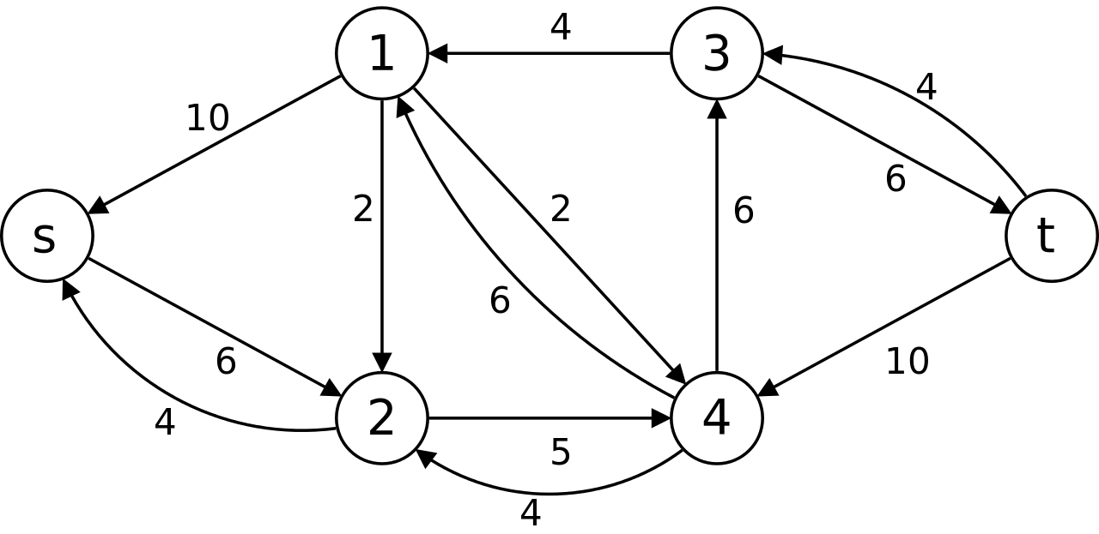

a) What is the MaximumFlow in the graph, show ALL augmented paths step-by-step

b) What is the Time complexity and Space of the algorithm?

c) Write the Java code for the algorithm?

3. Explain:

a) Cell, Gene, Chromosomes, DNA, Human Genome Project?

b) What is the relationships between elements in (a)

4. What are types of DNA mutations, Explain, give example for each.

5. In the article that I sent you:

<https://www.cancer.gov/about-cancer/treatment/types/precision-medicine/tumor-dna-sequencing>

a) What is Tumor DNA sequencing?

b) Which gene does the article identify as an example?, and the mutations in the identified gene

causes what kind of problem?

c) In this article what is the name of Gene and what is the root cause of cancer and how it is created?

<https://www.cancer.gov/about-cancer/treatment/types/precision-medicine/tumor-dna-sequencing>

6. Consider paper “Genetic Algorithms for Balanced Minimum Spanning Tree Problem”.

A) Read and understand only the first 5 pages.

<https://annals-csis.org/Volume_5/pliks/249.pdf>

B) Write Java code for **Algorithm-1** described in paper

C) Compile and Run the code

D) Discuss your Input Data, Data Structures, and Outputs

Reference: Balanced Spanning Tree

<https://stackoverflow.com/questions/4795983/balanced-spanning-tree-t-from-undirected-graph>